**INSIGHTSTREAM: NAVIGATE THE NEWS LANDSCAPE (REACT APPLICATION)**

**1.INTRODUCTION**

InsightStream is a revolutionary web application designed to redefine how people discover and consume news. It offers an intuitive interface, dynamic search, and a vast range of news categories for all types of users. Join InsightStream to embark on an informative journey and experience the future of news consumption.

* **PROJECT TITLE**: INSIGHTSTREAM: NAVIGATE THE NEWS
* **TEAM LEADER: SIVAKANDAN A**
* **TEAM MEMBER: SRINIVASAN J**
* **TEAM MEMBER: SURENDAR R**
* **TEAM MEMBER: VINAYAGAM M**
* **TEAM MEMBER: RIYAS BASHA**

**2.PROJECT OVERVIEW**

**PURPOSE:**

* InsightStream is a web application designed to redefine how people discover and consume news. It offers an intuitive interface, dynamic search, and various news categories, providing a seamless and engaging news exploration experience.

**FEATURES:**

* Access news from multiple API sources.
* Visual news exploration through curated image galleries.
* Advanced search functionality to find specific news articles.
* Intuitive design with a clean and modern user interface.:

**3.ARCHITECTURE**

**COMPONENT STRUCTURE:**

The project is structured into four main folders:

* Components: Houses reusable UI components such as the Navbar, Hero Section, News Cards, and Search Bar.
* Pages: Contains pages such as the homepage, category pages, and article detail pages.
* Context: Manages state using React Context API.
* Styles: Contains all the CSS files for styling.

**STATE MANAGEMENT:**

* Uses React's Context API to manage global state.
* Local state is handled within individual components for UI interactions.

**ROUTING:**

* React Router DOM is used for client-side routing.
* Users can navigate between categories, search results, and individual articles seamlessly.

**4.SETUP INSTRUCTIONS**

Here are the key prerequisites for developing a frontend application using React.js:

* **Node.js and npm:**

Node.js is a powerful JavaScript runtime environment that allows you to run JavaScript code on the local environment. It provides a scalable and efficient platform for building network applications.

Install Node.js and npm on your development machine, as they are required to run JavaScript on the server-side.

* + Download: <https://nodejs.org/en/download/>
  + Installation instructions: <https://nodejs.org/en/download/package-manager/>
* **React.js**:

React.js is a popular JavaScript library for building user interfaces. It enables developers to create interactive and reusable UI components, making it easier to build dynamic and responsive web applications.

Install React.js, a JavaScript library for building user interfaces.

* + Create a new React app:

**npm create-react-app my-react-app**

* + Replace my-react-app with your preferred project name.
  + Navigate to the project directory:

**cd my-react-app**

* + Running the React App:

With the React app created, you can now start the development server and see your React application in action.

* + Start the development server:

npm start or npm run dev

This command launches the development server, and you can access your React app at http://localhost:3000 in your web browser.

* **HTML, CSS, and JavaScript**: Basic knowledge of HTML for creating the structure of your app, CSS for styling, and JavaScript for client-side interactivity is essential.

* **Version Control**: Use Git for version control, enabling collaboration and tracking changes throughout the development process. Platforms like GitHub or Bitbucket can host your repository.

• Git: Download and installation instructions can be found at:

<https://git-scm.com/downloads>

* **Development Environment**: Choose a code editor or Integrated Development Environment (IDE) that suits your preferences, such as Visual Studio Code, Sublime Text, or WebStorm.

* + - Visual Studio Code: Download from <https://code.visualstudio.com/download>
    - Sublime Text: Download from <https://www.sublimetext.com/download>
    - WebStorm: Download from [https://www.jetbrains.com/webstorm/download](https://www.jetbrains.com/webstorm/download%20)

To install and run the Application project from google drive:

Follow below steps:

* **Get the code:**
  + Download the code from the drive link given below: <https://drive.google.com/drive/folders/1tDoSwd-1I3HsPJ9_92MnZTUtteeda-hL?usp=sharing>
* **Install Dependencies:** 
  + Navigate into the cloned repository directory and install libraries:

**cd news-app-react npm install**

* **Start the Development Server**
  + To start the development server, execute the following command:

**npm start**

**Access the App:**

* + - Open your web browser and navigate to [http://localhost:3000](http://localhost:3000/).
    - You should see the applications homepage, indicating that the installation and setup were successful.

You have successfully installed and set up the application on your local machine. You can now proceed with further customization, development, and testing as needed.

**5.FOLDER STRUCTURE**

**CLIENT**:

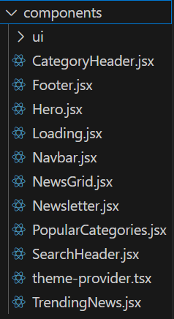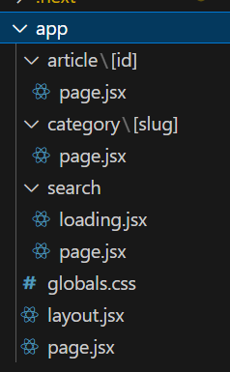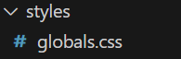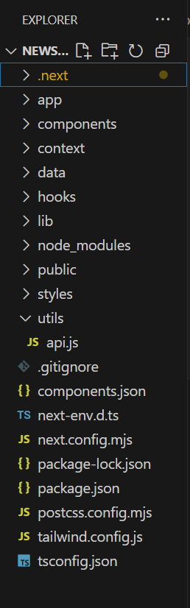

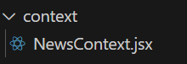

:

**UTILITIES:**

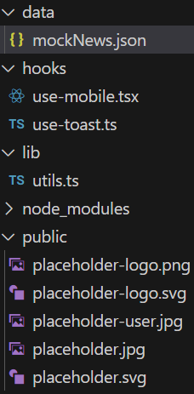

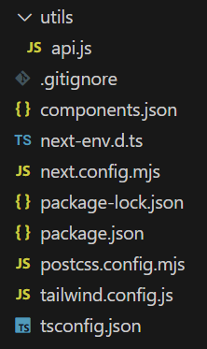

**6.RUNNING THE APPLICATION**

To run the application locally:

Navigate to the project folder and execute:

* + **npm start**

The application will be available at <http://localhost:3000>.

**7.COMPONENT DOCUMENTATION**

**Key Components:**

* Navbar: Navigation bar with links to categories and search.
* Hero Section: Displays trending news headlines dynamically.
* News Cards: Displays individual news articles.
* Search Bar: Allows users to search for news articles by keyword.

**Reusable Components:**

* Button Component: Styled button used across the app.
* Loader Component: Displays loading state when fetching news.

**8.STATE MANAGEMENT**

**GLOBAL STATE:**

* Managed using Context API for storing user preferences, bookmarks, and fetched news articles.

**LOCAL STATE:**

* Managed using React’s useState for UI interactions such as search input and dropdown selections.

**9.USER INTERFACE**

**SCREENSHOTS OR GIFS SHOWCASING DIFFERENT UI FEATURES, INCLUDING:**

**HOMEPAGE WITH TRENDING NEWS:**

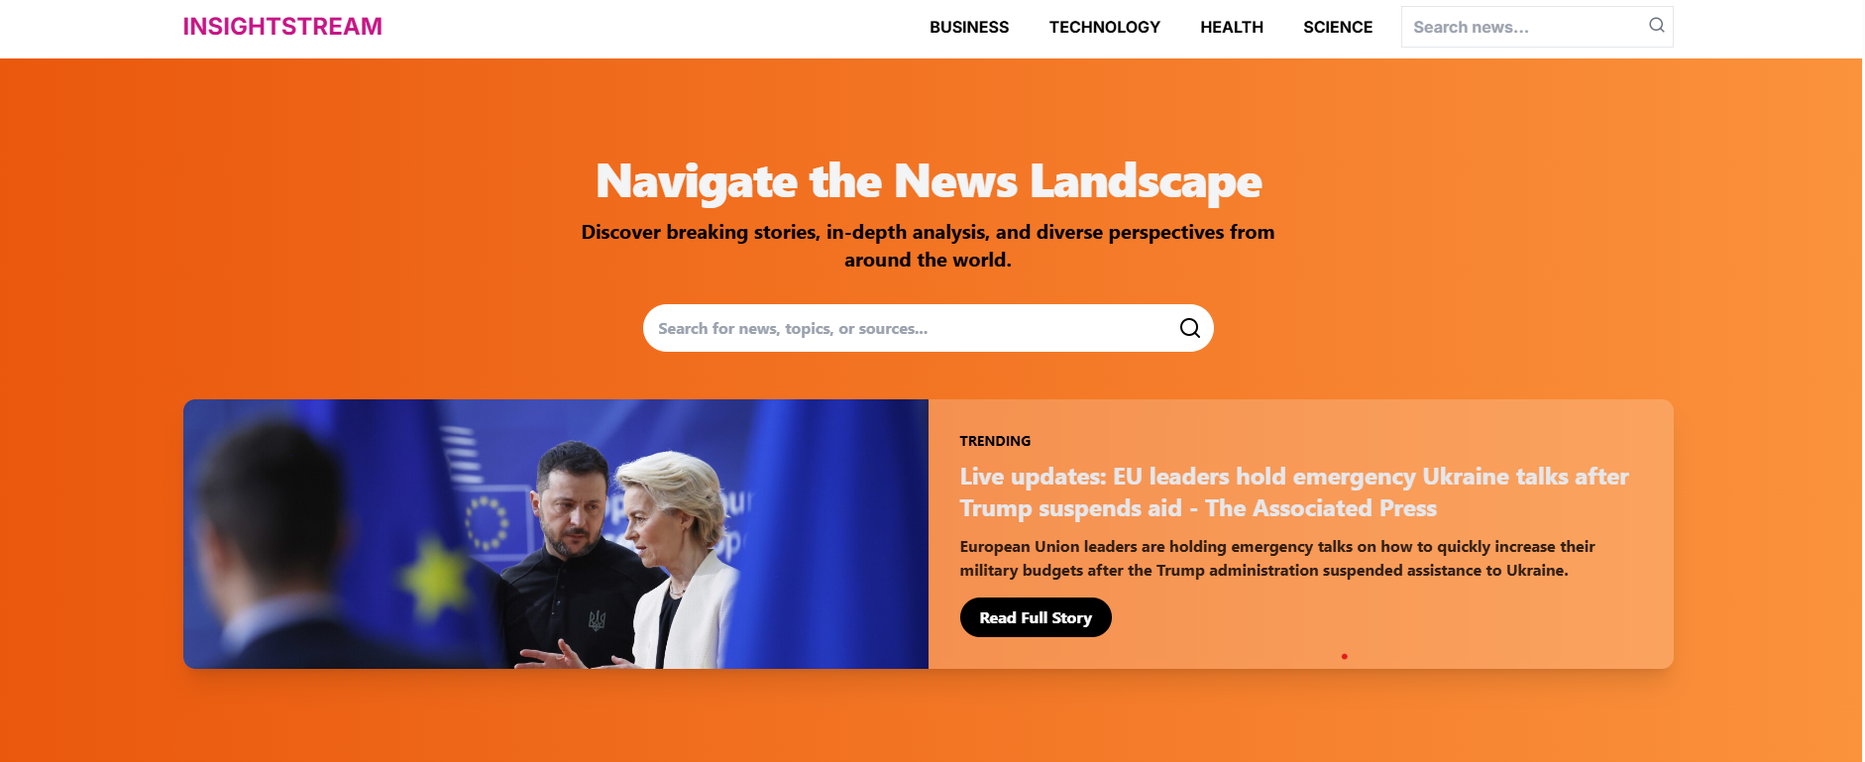

**CATEGORY PAGES:**

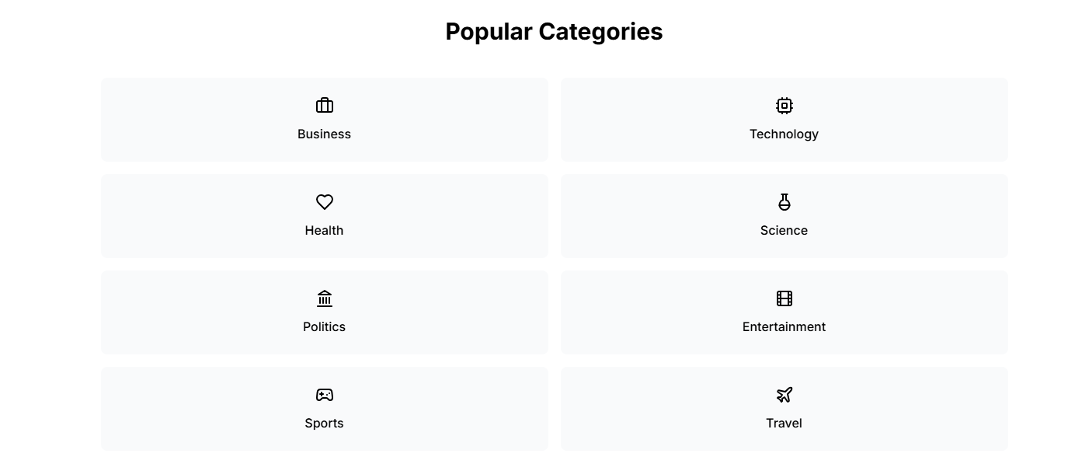

**ARTICLE DETAIL PAGE:**

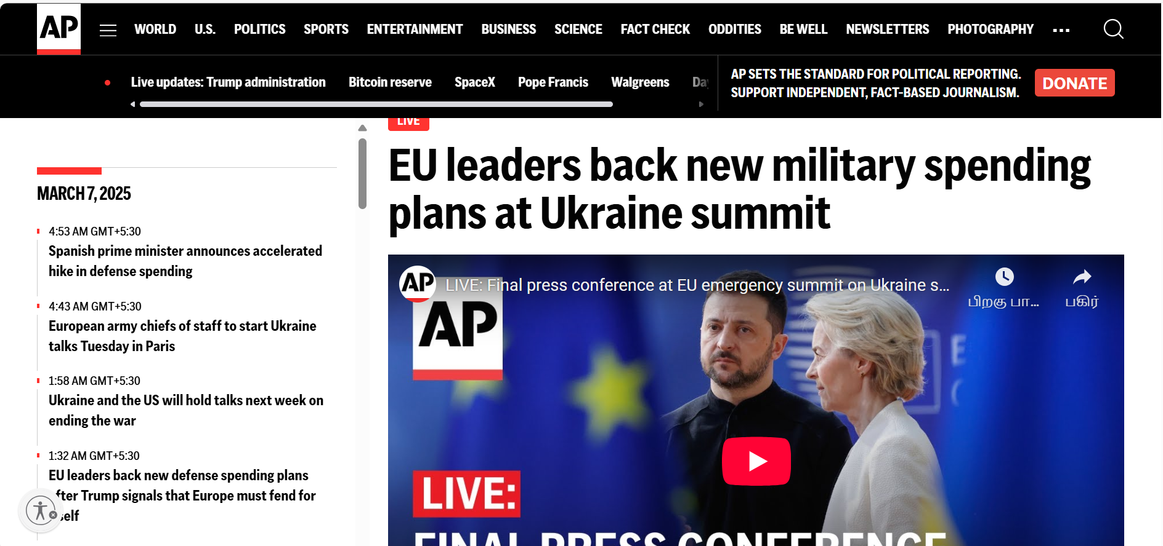

**SEARCH FUNCTIONALITY.**

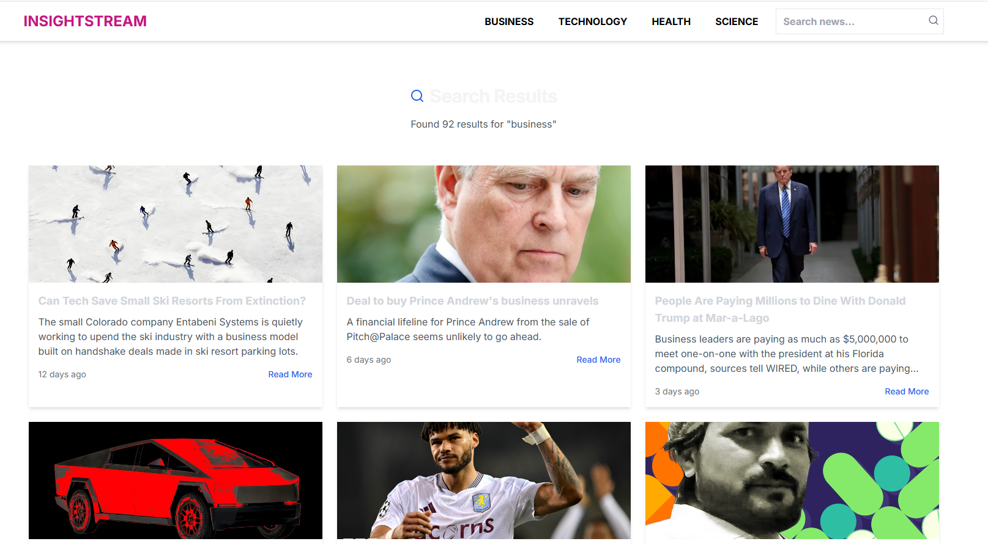

**FOOTER SECTION:**

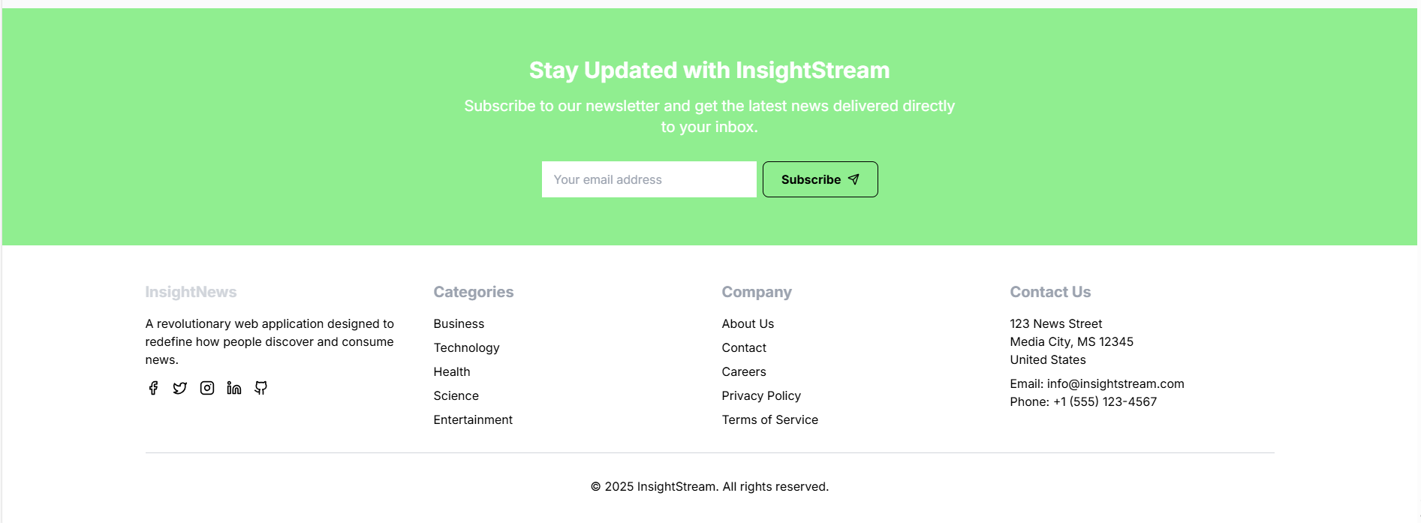

**10.STYLING**

**CSS FRAMEWORKS/LIBRARIES:**

* The project uses Bootstrap and Tailwind CSS for pre-built styles, utility classes, and responsive design.
* Global styles and reusable utility classes are managed using Tailwind CSS.
* Bootstrap components are used for layout, grids, and pre-defined styles.
* Inline styles are applied for specific component-level customizations where necessary.
* This ensures the documentation properly explains the styling approach without including actual CSS code.

**INLINE STYLES:**

* Some components use inline CSS for quick styling adjustments and dynamic styles.

**11.TESTING**

Testing ensures that the InsightStream application is stable, reliable, and performs well across different scenarios. The project follows a structured approach to test various components and functionalities, ensuring a seamless news-browsing experience for users.

**TESTING STRATEGY**

**Unit Testing**

* Each React component is tested individually to verify its rendering and behavior.

**Example:**

* Testing if the Navbar component renders correctly with all navigation links.
* Checking if the Search Bar properly updates user input.
* Verifying that the Category Cards display correct titles and images.

**Integration Testing**

* Ensures that multiple components work together as expected.

**Example:**

* Selecting a news category should update the displayed news articles.
* Clicking on a trending news article should redirect to the Article Detail Page.
* The Subscription Form should validate user input and store data.

**End-to-End (E2E) Testing**

* Simulates real user interactions to ensure the application flows correctly.

**Example:**

* A user searches for "Technology" and gets relevant news articles.
* A user clicks on an article and is redirected to the original news source.
* The Newsletter Subscription Form successfully registers an email.

**Tools Used for Testing**

* Jest – Used for unit and component testing in React.
* React Testing Library – Tests user interactions with components.
* Cypress (Optional for E2E Testing) – Automates user journeys like searching and clicking news articles.

**Code Coverage**

* The project ensures thorough test coverage using Jest.
* Run the following command to generate a test coverage report:

Now Type this Command in the Terminal or Command Prompt

* **npm test -- --coverage**

**Test coverage includes:**

* Component Coverage: Ensures all UI components render correctly.
* Functionality Coverage: Validates that API calls fetch news correctly.
* Navigation Coverage: Confirms smooth routing between pages.

This structured testing approach ensures InsightStream delivers a smooth and bug-free user experience.

**12.SCREENSHOTS OR DEMO**

**HOME PAGE WITH TRENDING NEWS**

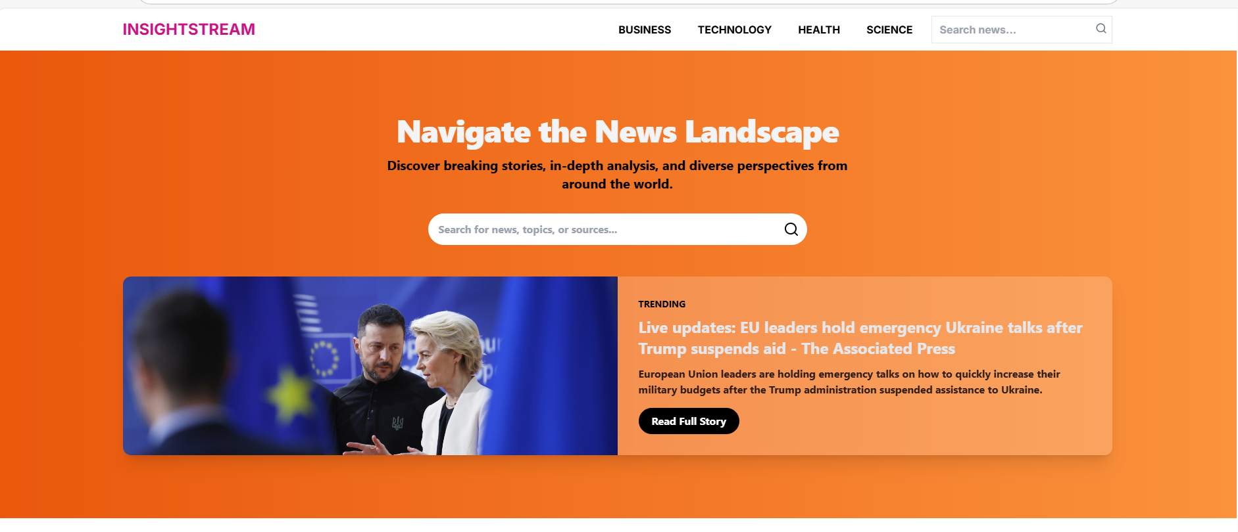

**CATEGORIES NEWS**

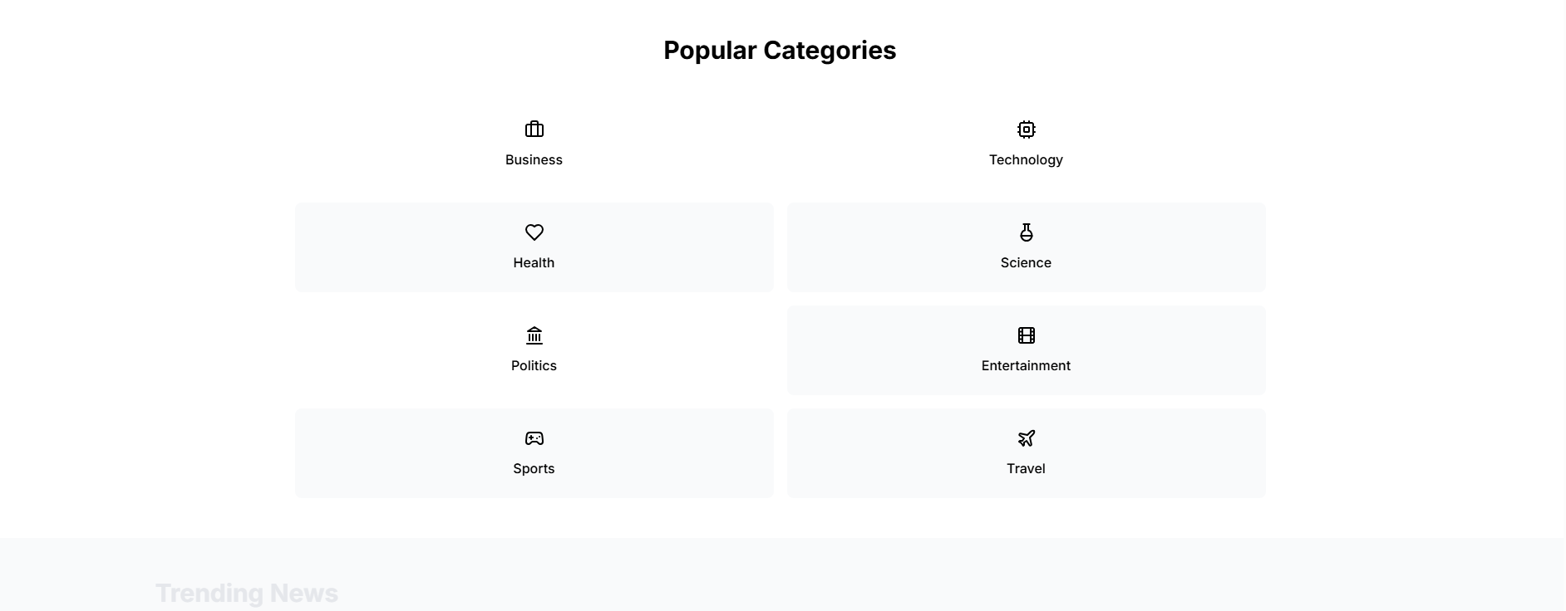

**TRENDING NEWS**

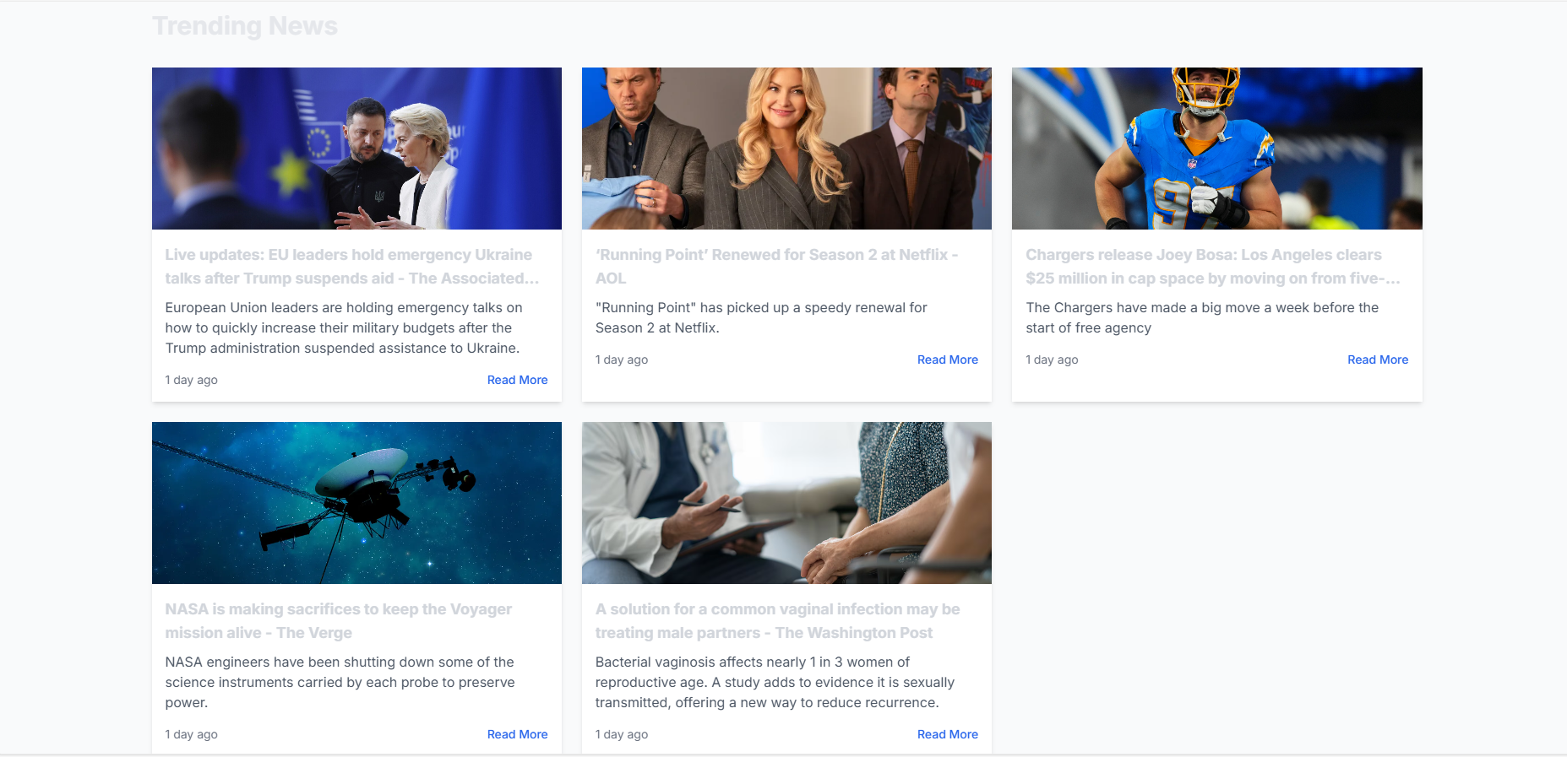

**FOOTER SECTION**

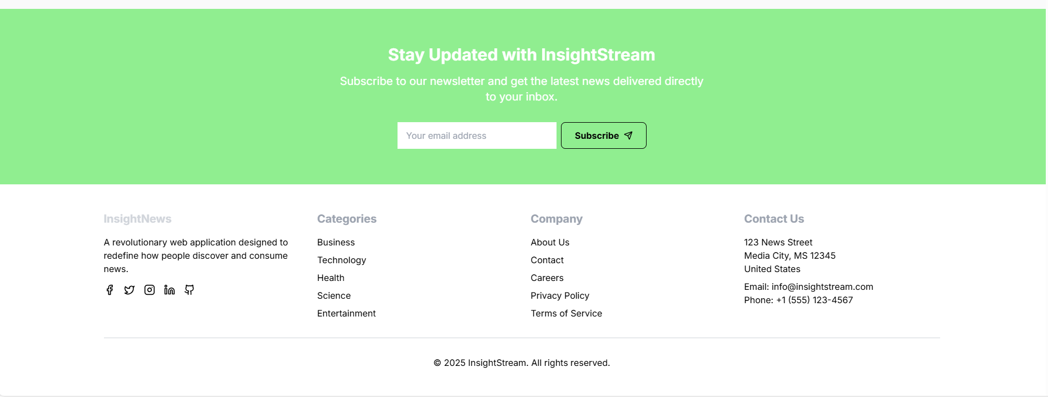

**BUSSINESS NEWS**

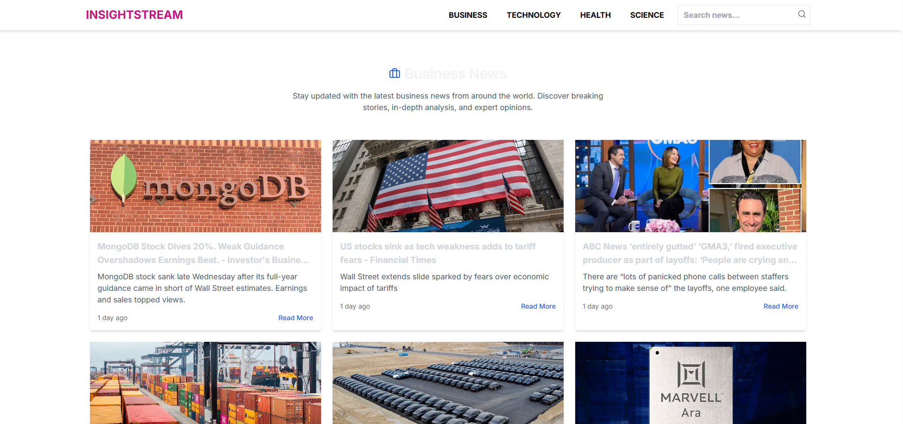

**TECHNOLOGY NEWS**

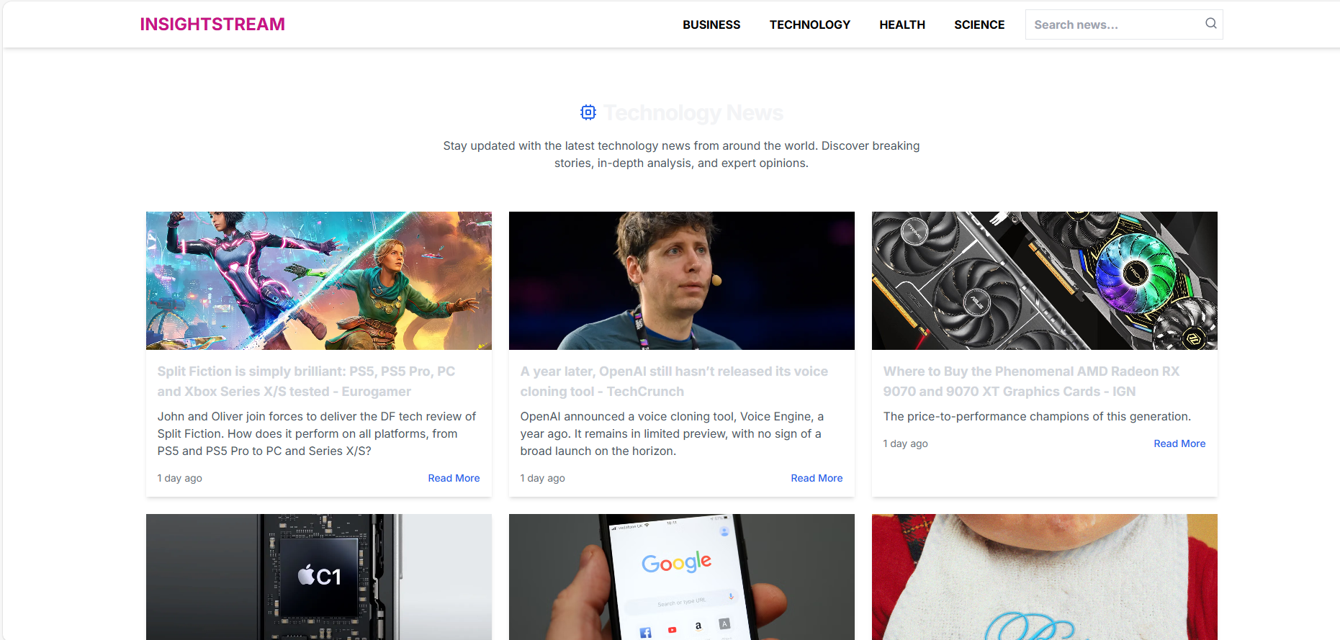

**HEALTH NEWS**

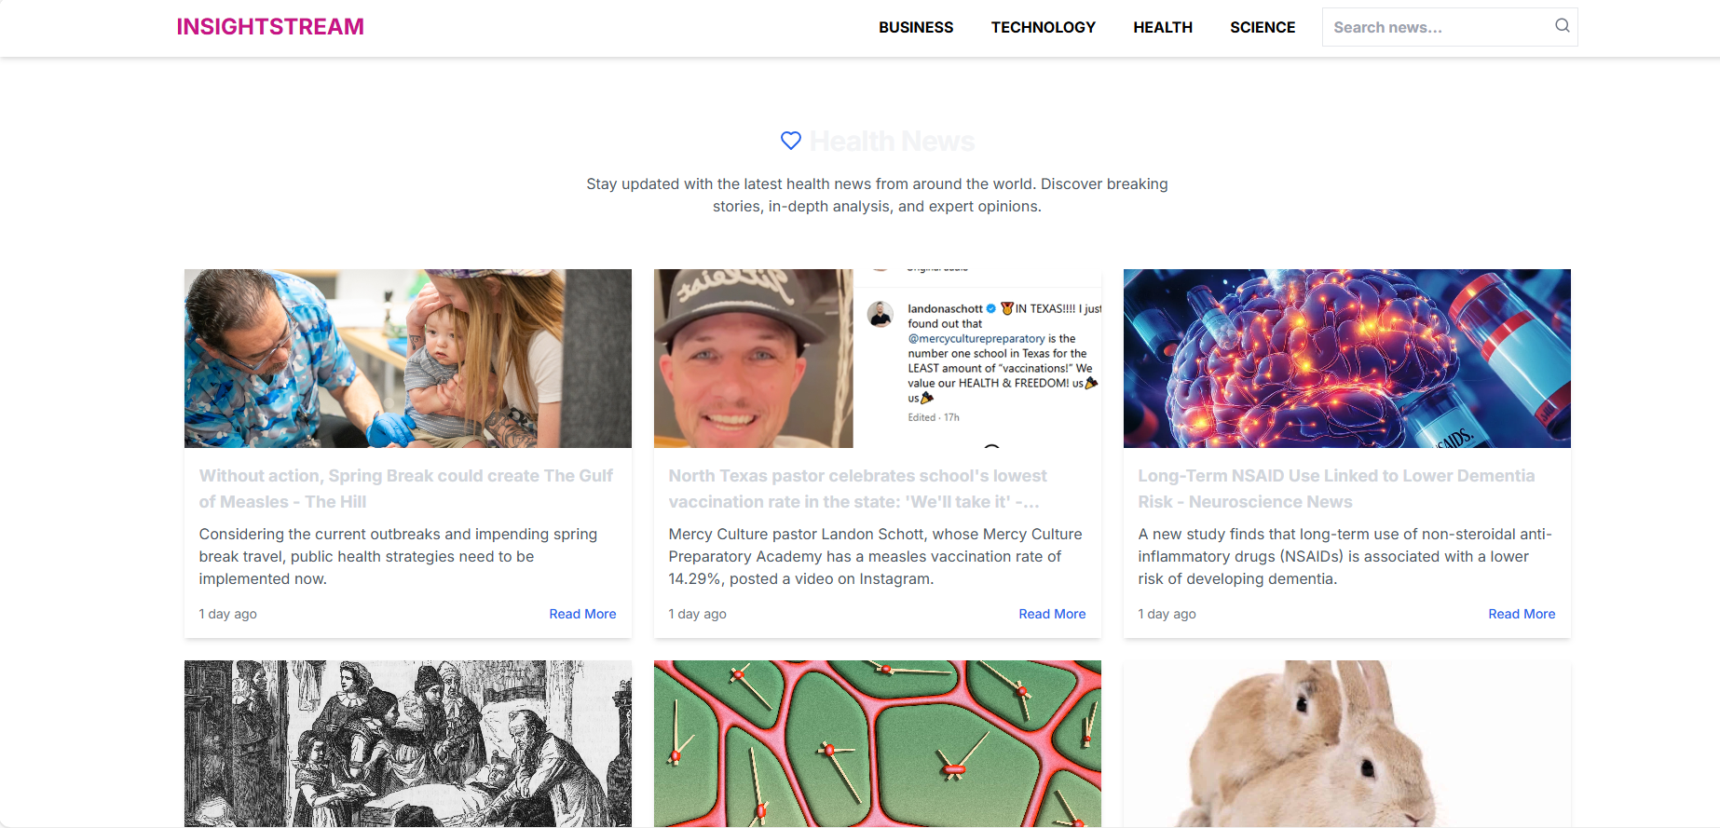

**SCIENCE NEWS**

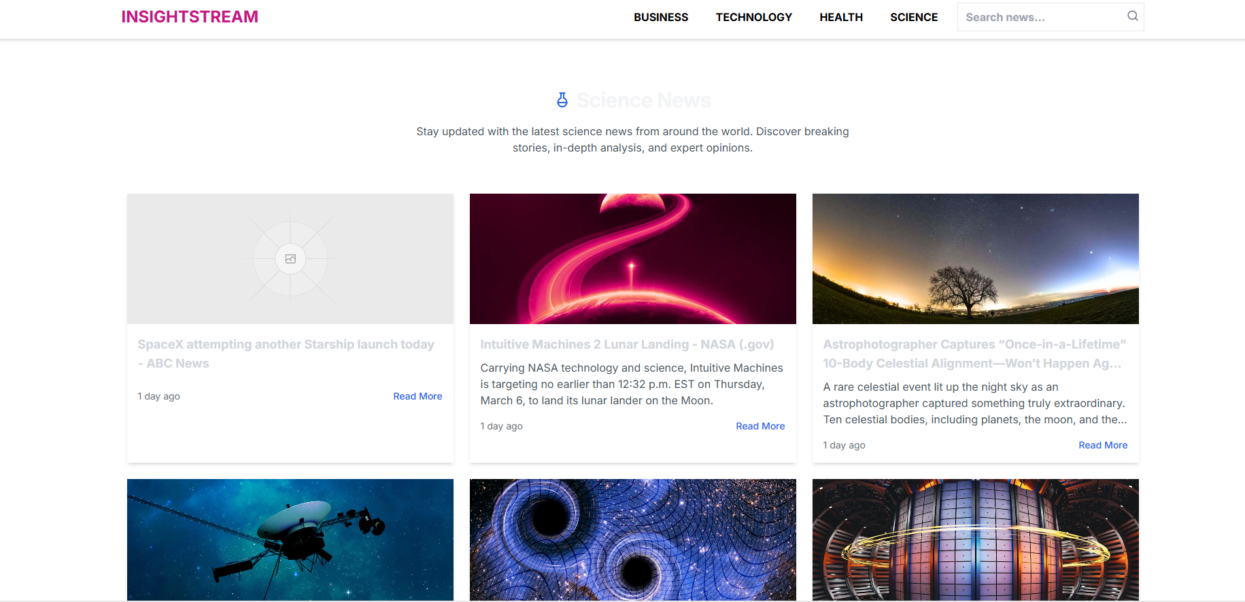

**13. KNOWN ISSUES**

* API Rate Limits – News API has a request limit per hour.
* Some Articles Missing Images – Some news sources don’t provide images.

**14. FUTURE ENHANCEMENTS**

* User Authentication – Allow users to create accounts and save favorite articles.
* Push Notifications – Notify users of breaking news.
* Infinite Scroll – Implement seamless scrolling for more news.

**15. CONCLUSION**

InsightStream is a powerful news aggregator that provides users with real-time news, categorized browsing, and an intuitive search feature. Future updates will include user authentication, bookmarks, and personalized news feeds.